

  - Chief Commercial Officer

Candidate pack
June 2026
 | About US  We’re NCVO. Together with our members, we’re here to make  society stronger.  We do this by equipping charities and voluntary organisations with the tools they need to drive positive change. From advice and guidance to training and events. As well as policy, influencing, research, and insight. We bring the sector together to tackle challenges we all share.  Whether it’s a small community group or a big national charity, we help organisations work better today – and improve the environment they’ll operate in tomorrow.  Because we know we can make the future better than the past.
 | The Challenges we’re facing  Right now, civil society is facing some big challenges:  - Funding volatility and financial strain  - Rapid digital and AI disruption  - Increasing policy volatility and a narrowing civic space  - Fragmentation across the sector, with smaller organisations disproportionately affected  Now more than ever, we need a strong, independent and representative civil society. Together, we’re committed to helping our members navigate this landscape.
 | The changes we’re making  To help tackle these challenges head-on, we’re redefining our role and clarifying the value we bring to civil society.  We’re shifting from being a broad, representative body to becoming a system-shaper – one that actively protects and strengthens civil society. We’re prioritising depth over breadth: grounding our work in evidence and focusing our authority where it matters most. And we’re shifting our  energy away from service-heavy delivery towards influence, data, convening and brand-led initiatives – the areas where we can make the greatest difference.  All so that our impact is sharper, more sustainable, and more clearly felt across the sector.

  - Chief commercial Officer
Driving sustainable growth and sector impact

We’re looking for an ambitious and values-driven commercial leader to shape the future sustainability and growth of our mission-led organisation.

As Chief Commercial Officer, you’ll lead the commercial strategy at the heart of the organisation – driving income growth, strengthening membership engagement, and building high-value partnerships that amplify our influence and impact across the voluntary sector.

As a member of the Executive Team, you’ll translate organisational priorities into a clear and ambitious commercial vision, ensuring financial resilience while delivering genuine value for members, partners and stakeholders.

Your Key Responsibilities

Setting strategic direction | Growing income and commercial impact | Strengthening membership
You’ll lead the development and delivery of an integrated commercial strategy that brings together membership, partnerships, fundraising and commercial services into a coherent, high-performing offer. Your work will ensure commercial sustainability remains central to organisational success and long-term impact. | You’ll drive sustainable income growth across consultancy, training, partnerships, sponsorship, grants and membership. Through strong commercial leadership, market insight and business development discipline, you’ll identify opportunities, manage risk and ensure ambitious financial targets are achieved. | You’ll oversee the strategic development of a compelling membership offer that strengthens recruitment, retention and engagement across a diverse membership base. You’ll ensure member insight informs organisational strategy and that relationships with members and stakeholders continue to deepen and evolve.
Building partnerships | innovation and customer excellence | Executive leadership and impact
You’ll build and sustain high-value relationships with corporate partners, funders, sector bodies and key stakeholders. As a visible external ambassador, you’ll strengthen organisational reputation, create meaningful collaborations and position the organisation as a trusted partner and leading voice within the sector. | You’ll champion a culture of innovation, continuous improvement and customer excellence across all commercial activity. From developing new products and services to enhancing customer experience and digital engagement, you’ll ensure commercial offers remain relevant, high quality and impactful. | Working closely with the CEO, Board and Executive Team, you’ll contribute to organisational strategy, governance and decision-making at the highest level. You’ll lead a high-performing directorate with clarity, ambition and integrity, balancing commercial success with mission, values and long-term sustainability.

Why this role matters
In a challenging and fast-changing funding and policy environment, strong commercial leadership is critical to ensuring sustainable impact. In this role, you’ll:
- Drive sustainable income growth that supports long-term organisational resilience
- Strengthen and grow engagement with a 17,000-strong membership community
- Build influential partnerships that extend reach, reputation and impact
- Lead innovation across commercial services, products and customer experience
- Contribute at the highest level of organisational leadership and strategy
This is a role for a commercially astute, strategic and collaborative leader who thrives at the intersection of income growth, partnership development and mission-driven impact.

OUR STRUCTURE

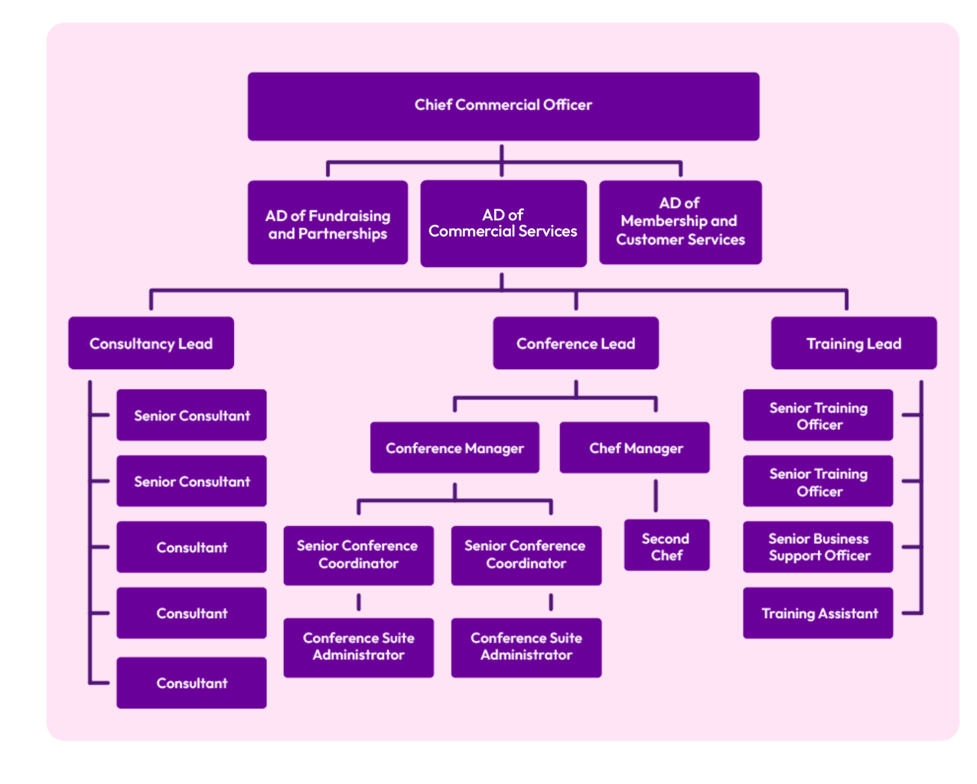

Benefits we offer
Working at NCVO comes with a range of attractive benefits, including:

- 25 days’ annual leave (pro-rata for part-time staff) and office closure between 25 December and 1 January inclusive. After three years' service annual holiday increases to 27 days, and after five years to 30 days, (pro rata for part time staff)
- the option to purchase up to five more days each year
- five days’ volunteering leave (pro rata for part-time staff)
- 2.5 extra ‘wellbeing’ days off during the year
- enhanced pay for maternity/adoption leave
- subsidised gym membership
- season ticket loan
- flexible working, including opportunities to work from home/off site
- monthly homeworking allowance for permanent homeworkers
- generous employer pension contribution of up to 8.5% of salary, into our stakeholder pension scheme (linked to employee contribution)
- training and development opportunities
- the opportunity to join Hospital Saturday Fund health cash plan for free at the basic level of cover, or at a reduced rate for other levels of cover
- 24-hour free and confidential employee assistance programme
We’re located a short walk from London King’s Cross station in a modern accessible building, overlooking Regent’s canal.

THE TIMELINE

26 June 2026 6pm | Applications close
w/c 29 June 2026 | Shortlisting
w/c 6 July 2026 | Interviews

