

DELEGATE Documentation
7 Proven Strategies to help you Sell more Sponsorship
Masterclass
30 June 2020

Presented by:
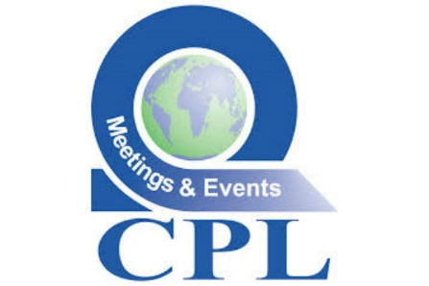

Introduction from the Workshop Leader
It’s my pleasure to be here today, to work with you on this topic. Thank you for coming and I hope to make our time together worthwhile for you.

Enjoy this mini masterclass and please feel free to connect with me and share anything that occurs to you as we work. My social media details are as follows:

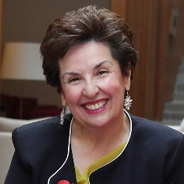 | Twitter: @lindacpl  LinkedIn: www.linkedin.com/company/cpl-meetings-events  Website: www.cplevents.pt  Email: linda@cplevents.pt
About the trainer
Linda is passionate about associations and is particularly active in the professional associations in her own field. She is also a consultant to a variety of associations. In 2008 she was considered one of Portugal’s five most influential people in the conference & events industry and received the education award from IAHMP. Respected internationally as a speaker she has lectured in countries such as Italy, Spain, Russia, Egypt, Cape Verde, United Kingdom, Dubai, Spain and The Netherlands. In 2009 she received the medal of honour for positive entrepreneurship in Portugal for her commitment to promoting culture and heritage and for CSR initiatives.

Programme
Sponsorship is forever harder to acquire and keeping up to date on what works is essential to your livelihood. In times of online events the challenges are greater but can be overcome.
During this one-hour Masterclass, the tutor will present on how sponsorship of events and the association can be increased.
Linda Pereira, an association expert for over 20 years, and on the board of many associations, has extensive experience in developing revenue streams for associations all-year-around as well as for events. Delegates will benefit from her considerable knowledge and experience, tutored in an engaging style with authority.
What you will learn:
- What corporate are telling us and what sponsors do not like
- Your communication is hurting you – how to change it
- New sponsorship package
- Building longer term partnership agreements
- When in Rome – do not do what Romans do!

Timings
15:00 – Welcome & Introduction
16:00 – Close of Masterclass

Exercise

- What three major benefits would the sponsor obtain from your meeting/event?
- What three innovations have you added to your meeting over the last 2 editions?
- What do you believe would be my first three questions as a potential sponsor?

Reflections:
Corporate & Sponsors

Reflections:
Communication

Reflections:
Sponsorship packages

Reflections:
Building partnership agreements

The Association of Association Executives (AAE) supports employees and officers of membership organisations in their own development and that of the services, products and events they provide their own communities.
Members are from professional, scientific, learned and business associations, societies, federations, councils, chambers, and other membership organisations, in all sectors. Over 24,000 members and subscribers are located in Europe including the United Kingdom, in Africa, India and many other countries and regions.
www.associationexecutives.org

CPL Meetings & Events
CPL Meetings & Events are a British-Portuguese company with international ambition fascinated by the world surrounding us. We recognize the importance of specific know how in the areas of our clients in order to ensure a successful communication, message delivery, congress, conference or meeting. Our expertise and know-how allows us to offer our clients, whether they represent associations, companies or public entities, creativity and the capacity to implement ideas. Our mission is to work together with our clients in search for the best solutions and to guarantee the success of each project in all aspects.
For more information please view their website using the link below:
https://www.facebook.com/cplmeetingsevents/

