Job title | Business Support Administrator
Directorate | Homes and Wellbeing | Service | Business Support
Reporting to  Post title (not person). | BST Admin Team Leader | People manager | No
Scale number & job family | 2 – CX/Admin | Work style | Office based
DBS requirements | None | Role profile reviewed | 20/01/2026

About the role
Purpose
To provide a comprehensive administrative service to support the work of Homes & Wellbeing and to provide a postal service to head office teams.

Main responsibilities
Provide a postal service including:
- Process all incoming mail on a daily basis;
- Distribute internal and external mail to departments/colleagues as required, either by hand or electronically;
- Process and send all outgoing post, either franked or special delivery;
- Maintain franking machine and post supplies;
- Provide a print and post service to head office H&W teams;
- Process social value surveys and service user surveys.

Oversee stationery at Head Office and process requests for other NCHA offices by:
Ensuring main stock levels are kept by monitoring stores and logging activity on spreadsheet.
Restock stationery cupboards throughout the Clifton Office
Process order requests for stationery
Order general stationery when stocks require it and check items once delivery is received
Update and maintain the department’s key information database and electronic filing systems; processing time critical information using IT systems in accordance with procedures.
Arrange parking permits via local authorities
Process Fobs and send out when requested
Maintain and produce service user guides and arrange the issue of service user surveys to all service users;.
Log and process local authority expressions of interest for registered care home vacancies.

Maintain archiving process: arrange archiving, maintain database and arrange file destruction in line with NCHA’s retention schedule.
Maintain a basic understanding of the different departments within NCHA; scheduling bi annual project visits to each project; liaising with project managers and the HW Management team.
Provide a comprehensive administrative support to the team e.g.:
Filing, photocopying, shredding,
Producing mail merge standard letters and documents
Assisting with electronic diary management etc.
Processing invoices and requests for goods and services
Raising and confirming receipt of eBis orders - inc colleague uniforms and legal requests
Sourcing cost effective goods and services
Manage the team inbox and take appropriate action in response to queries and requests
Keep the team informed of all relevant issues relating to the effective delivery of services.

About the person (criteria used to shortlist applications)
Knowledge

Skills and experience
Demonstrable good level of numeracy and literacy skills

Substantial experience in an administrative role incorporating a wide variety of tasks, good organisational skills, good team work and the ability to prioritise

Demonstrable good word processing skills

Experience of using IT applications to produce a range of documents and to manipulate and transfer data including mail merges

Experience of dealing with customers and suppliers

Personal qualities, values and behaviours
Understanding of the needs of people from diverse social / cultural / racial backgrounds

Willingness to promote and adhere to the CLEAR values of NCHA

Other role related requirements
None

All post holders are expected to understand and comply with NCHA’s policies and procedures on Finance, Technology Services, Data Protection, Health & Safety, Equality and Diversity and any departmental policies in relation to the duties of the post.
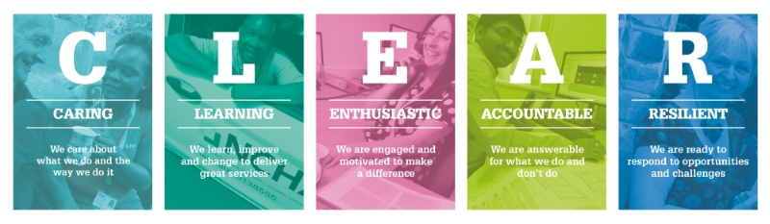
This is not a complete list of duties and responsibilities for the role, it does not form part of contractual terms and conditions. You may be required to carry out other duties commensurate with the grade of the role.

